First Baptist Church, Pastor LaMarr Pirkle March 31, 2019

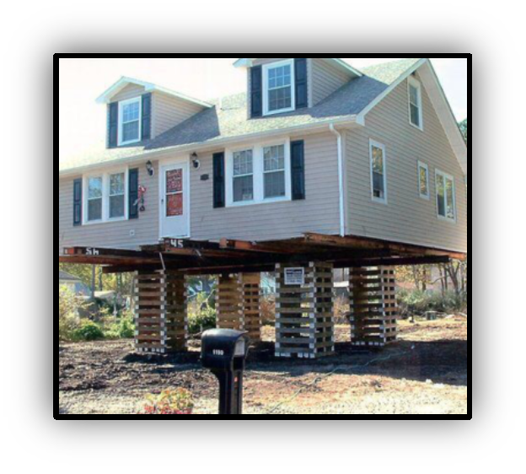

Jesus Christ, the One and Only True Foundation
Luke 6:46-49

1. Why do you call me _________________?

- Luke 6:46, Matthew 7:21, I John 1:8

2. _________________ to Christ is not optional.

- Hebrews 12:14, Romans 6:15-18, I Peter 1:22-23,
Matthew 7:21

3. Withstanding the _________ of time and eternity.

- Luke 6:47-48, James 4:13-17

4. ________________ sudden and final destruction.

- Luke 6:49, Matthew 7:23, Hebrews 4:13

First Baptist Church, Pastor LaMarr Pirkle March 31, 2019

Jesus Christ, the One and Only True Foundation
Luke 6:46-49

1. Why do you call me _________________?

- Luke 6:46, Matthew 7:21, I John 1:8

2. _________________ to Christ is not optional.

- Hebrews 12:14, Romans 6:15-18, I Peter 1:22-23,
Matthew 7:21

3. Withstanding the _________ of time and eternity.

- Luke 6:47-48, James 4:13-17

4. ________________ sudden and final destruction.

- Luke 6:49, Matthew 7:23, Hebrews 4:13

